Unit I – The Rise of Europe
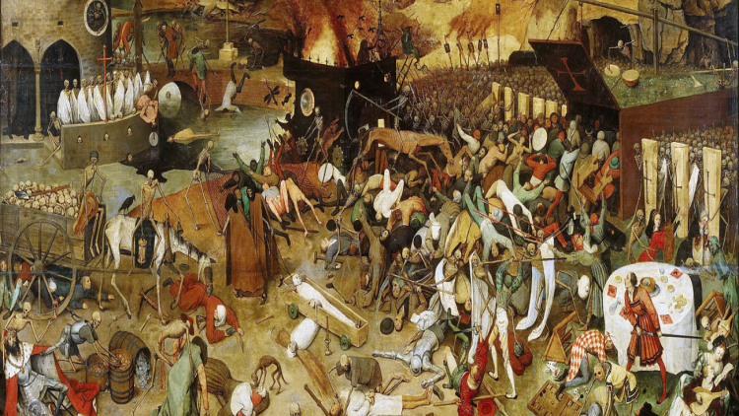
(1-1) Black Death & Hundred Years’ War – pg. 35 – 46
Guided Reading Questions

Answer the question or define the term for each:

Black Death

Preconditions and Causes
- What made Europe’s population so highly vulnerable to the bubonic plague?

- How did the bubonic plague enter Europe and how was it spread?

Popular Remedies
- What did popular wisdom of the time believe was the cause of disease?

- What were the ways in which people tried to remedy themselves of the plague?
People to Know
- King Edward III (r.1327-1377)
- King Philip VI (r.1328-1350)
- King Henry V (r.1413-1422
- King Charles VII (r.1422-1461)
- Joan of Arc (1412-1431)
- Looking at Map 9-1, what do the green areas of the map that didn’t experience widespread plague have in common?

- In some areas, who were blamed for the spread of the disease?

Social and Economic Consequences
- Briefly describe how the Black Death contributed to the following events:
Farms Decline –

Peasants Revolt –
Terms to Know
- Black Death
- Flagellants
- Hundred Years’ War
- Estates General
- English longbow

Cities Rebound –

- Who lost the most power due to the Black Death?

New Conflicts and Opportunities
- What conflict erupted within European guilds?

Hundred Years’ War and the Rise of National Sentiment
- How were English and French kings able to maintain order on such a grand scale?

The Cause of the War
- Briefly describe how each of the following were caused of the Hundred Years’ War:
Key Events
1337-1453 – Hundred Years’ War
1337 – Hundred Years’ War begins
1346 – Battle of Crecy
1347-1351 – Black Death hits Europe
1381 – English peasants revolt
1415 – Battle of Agincourt
1429 – Siege of Orléans
1453 – Fall of Constantinople
1453 – Hundred Years’ War ends

French throne –

French territory –

Flanders –

prejudice/animosity –

- What were the reasons for French weakness/failures in the first half of the war?
financial –

military –

Progress of the War
- What impact did the following treaties Treaty of Brétigny-Calais have on the Hundred Years’ War?
Treaty of Brétigny-Calais (1360)

Treaty of Troyes (1420)

- What impact did Joan of Arc have on the end of the war and what was her eventual fate?

- What impact did the Hundred Years’ War have on the nations involved?
France –

England –

