Unit XI – Global Conflicts
(11-1) The Soviet Experiment – pg. 704–716
Guided Reading Questions
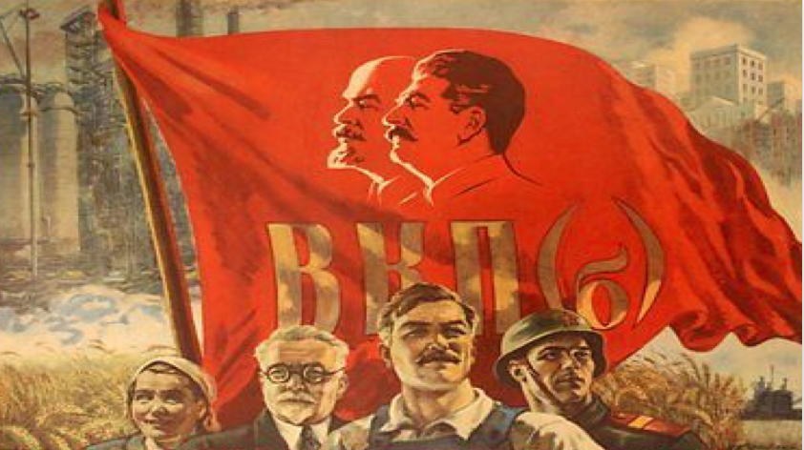
Answer the question or define the term for each:

The Interwar Years: The Challenge of Dictators and Depression
People to Know
- Leon Trotsky (1879-1940)
- Joseph Stalin (1879-1953)
- John Maynard Keynes (1883-1946)

- What two factors accounted for the bold experiments in politics and economic during the 1920s and 1930s?

After Versailles: Demands for Revision and Enforcement
Terms to Know
- Great Depression
- mixed economy
- Weimar Republic
- Sinn Fein
- Popular Front
- War Communism
- New Economic Policy
- Comintern (3rd International)
- Five-Year Plans
- collectivization

- What seems to have contributed the most to domestic political turmoil during the period after the Great War?

Toward the Great Depression in Europe
- What three factors helped to extend the length of the Great Depression?

Financial Tailspin
- How did France alienate itself against Britain?

- How was America partly responsible for the financial crisis that struck Europe?

Problems in Agricultural Commodities
- How did the collapse of agricultural commodities further contribute to the Depression?

Key Events
1918-1920 – Russian Civil War
1919/20 – Comintern formed
1921 – Lenin outlines New Economic Policy
1929 – Great Depression begins
1929 – Stalin’s 5-Year Plans begin
1929 – Soviet collectivization begins
1934-1939 – Great Purges
1936 – Popular Front takes office

Depression and Government Policy in Britain and France
- Explain the difficulties Britain had over the island of Ireland?

- In what way were the political governments of France and Britain similar during the 1930s?

The Soviet Experiment
- How were the Bolsheviks different than the Fascists and National Socialists in their ascension to power?

- Describe the Communist Party and their early ideology concerning their role in the world.

War Communism
- How did War Communism influence public policy by the Soviet government?*

- How did the Community Party handle opposition to its authority?

The New Economic Policy
The Third International
- What impact did the Russian Revolution have on the relationship between socialists and communists/Bolsheviks?

- What were the conditions of the Comintern? What was its purpose? What was its impact?
conditions –

purpose –

impact –

- How did the separation of socialist parties and the resulting feud between them impact Europe during the 1920s and 1930s?

Stalin versus Trotsky
- What were Trotsky’s and the left-wing views of Russia’s future?

- What ere Stalin’s and the right-wing views of Russia’s future?**

- How was Stalin able to advance and dominate leadership and politics within the Communist Party?

The Decision for Rapid Industrialization
- What was Stalin’s goal in rapid industrialization and what industries were impacted?
goal –

industries –

- What were the results of Stalin’s Five-Year plans?

The Collectivization of Agriculture
- How was collectivization enforced AND what happened to those that refused?

- Did Stalin’s collectivization of agriculture fix the problem of production?

The Purges
- What were the two rationales for the Great Purges?

