Unit XI – Global Conflicts
(11-2) The Rise of Fascism – pg. 716–738
Guided Reading Questions
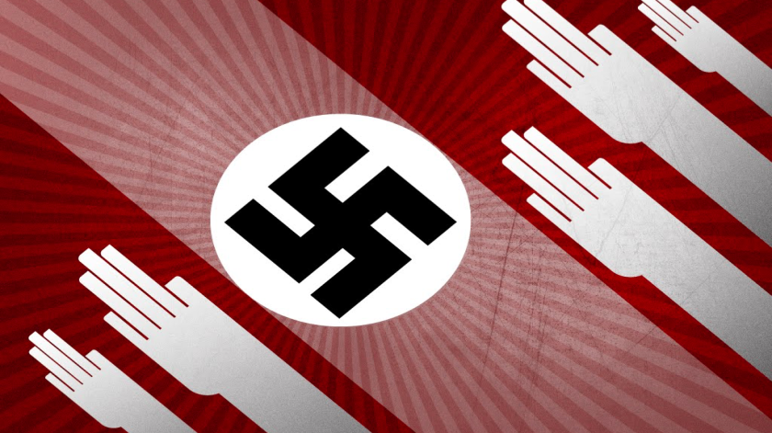
Answer the question or define the term for each:

The Fascist Experiment in Italy
People to Know
- Benito Mussolini (1883-1945)
- Adolf Hitler (1889-1945)
- Heinrich Himmler (1900-1945)

- Describe the fascist government.

The Rise of Mussolini
- What resentments were held by the “Band of Combat”?

- How did Mussolini’s actions in the face of government inaction help him rise to power?
Terms to Know
- fascism
- Weimar Republic
- Reichstag
- Nazis
- SA
- Mein Kampf
- Kellogg-Briand Pact
- police state
- SS
- Nuremberg Laws
- Kristallnacht
- Final Solution

- Was Mussolini’s rise to power legal?

The Fascists in Power
- Describe how the fascists were able to gain control over Italy.

- How did the Lateran Accord fix a half-century-old problem?

German Democracy and Dictatorship

The Weimar Republic
- Why was the Weimar Republic so highly criticized?

- What were the flaws within the Weimar Constitution?

- How did the social and economic upheaval of the early 1920s make Germans so desperate for order and security?
Key Events
1919 – Weimar Republic formed
1920 – Nazi Party is formed
1922 – Mussolini becomes prime minister
1922 – Mussolini given dictatorial power
1923 – French invade the Ruhr
1923 – Hitler conducts Beer Hall Putsch
1925 – Locarno Agreement
1928 – Kellogg-Briand Pact signed
1933 – Hitler becomes chancellor
1933 – Reichstag fire
1933 – Enabling Act
1934 – Night of the Long Knives
1934 – Hindenburg dies/Hitler made Führer
1935 – Nuremberg Laws passed
1935 – Hitler begins to rearm Germany
1938 – Kristallnacht
1942 – First stages of the Holocaust begin

- What was Hitler’s definition of “socialism”?

- How were Hitler and Mussolini similar?

- How was Hitler’s book, Mein Kampf, received?

- What two lessons did Hitler learn during his imprisonment?

- What impact did the Locarno Agreements have on Britain, France, Germany and Italy?

- How might the Locarno Agreements and Kellogg Briand Pact be seen as an uneasy peace?

Depression and Political Deadlock
- How did the Great Depression benefit the Nazis?

Hitler Comes to Power
- Describe Hitler’s attempts to gain power prior to being named chancellor.

Hitler’s Consolidation of Power
- In what three ways was Hitler able to consolidate power?

- What national incident did Hitler and the Nazis use to their advantage?

- How did the Night of the Long Knives/Nazi Purge (June 30, 1934) alleviate concerns of the German army?

Anti-Semitism and the Police State
- Describe the increasing anti-Semitic stages that occurred within Nazi Germany.
Nuremberg Laws –

Kristallnacht –

The Final Solution –

Racial Ideology and the Lives of Women
- What role did women play in the Nazi regime?

Nazi Economic Policy
- What two areas of the economy were essential to the Nazi economic policy?

Trials of the Successor States in Eastern Europe
Economic and Ethnic Pressures
Poland: Democracy to Military Rule
- Why was Poland hard to govern over?

Czechoslovakia: A Viable Democratic Experiment
- How were Poland and Czechoslovakia similar to prewar Austria?

Hungary: Turn to Authoritarianism
Austria: Political Turmoil and Nazi Occupation
Southeastern Europe: Royal Dictatorships
- What was the prevailing governmental structure of southeastern Europe?

Please read the “IN PERPECTIVE” section for an overview of the chapter.

