Unit XII – The Long Peace
(12-2) Decolonization and the Collapse of European Communism – pg. 803 –832
Guided Reading Questions
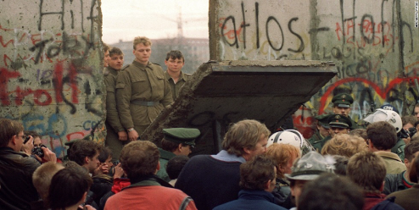
Answer the question or define the term for each:

Decolonization: The European Retreat from Empire
People to Know
- Mohandas Gandhi (1869-1948)
- Charles de Gaulle (1890-1970)
- Ho Chi Minh (1892-1969)
- Mikhail Gorbachev (1931- )
- Boris Yeltsin (1931-2007)
- Slobodan Milosevic (1941-2006)
- Vladimir Putin (1952- )
- How did decolonization complicate the Cold War*?

Major Areas of Colonial Withdrawal

India
- What tactic does Gandhi use to help promote Indian nationalism?

- What reoccurring factor plagued colonies after decolonization (still a factor today*)?

Further British Retreat from Empire
- How does African decolonization differ from Asian decolonization?

The Turmoil of French Decolonization
- Why was France do resistant to decolonization?
Terms to Know
- decolonization
- Vietnamization
- perestroika
- glasnost
- ethnic cleansing
- radical Islamism
- jihad

France and Algeria
- How did French actions/inactions fuel Algerian nationalism?

- How did Charles de Gaulle return to politics mark a major shift in French colonial policy?

France and Vietnam
- Why did the U.S. become interested in Vietnam?

Vietnam Drawn in the Cold War
Direct United States Involvement
- What impact did U.S. intervention in Vietnam have on Western Europe?

The Collapse of European Communism
- How was the Soviet Union’s collapse unique and unprecedented in modern European history?
Key Events
1915 – Gandhi returns to India
1945-1991 – The Cold War
1947 – India gains independence
1956 – Vietnam gains independence
1962 – Algeria gains independence
1964-1973 – Vietnam War
1979 – Iranian Revolution
1985 – Mikhail Gorbachev become the Soviet Premier
1989 – Democratic revolutions in Eastern Europe
1989 – Berlin Wall/Iron Curtain falls
1990 – Germany is reunified
1991 – Yugoslavia begins to break up
1991 – Soviet Union collapses
1992 – Bosnian War begins

Gorbachev Attempts to Reform the Soviet Union
- How might Gorbachev’s policy of perestroika be considered a beginning victory for capitalism and the West?

- How might Gorbachev’s policy of glasnost be seen as a full retreat from “Stalinism”?

1989: Revolution in Eastern Europe
- How are each of the following nations engaged in “revolutionary” action?
Poland –

Hungary –

Germany –

Soviet Union –

The Collapse of the Soviet Union
- Describe the three forces working against Gorbachev’s policies

- Describe the events that led to the collapse of the Soviet Union.

The Yeltsin Decade
- Describe at least TWO major events the occurred during Yeltin’s decade in office?

The Collapse of Yugoslavia and Civil War
- How might problems within Yugoslavia be compared to the former Austrian Empire?

- Why did war break out between Serbia and Croatia?

- How are the events in Bosnia similar to the events surrounding the Holocaust?

- Why is the 1999 bombing campaign a milestone in recent European history?*

Putin and the Resurgence of Russia
- What two actions has Putin become very critical of?

- What did the invasion of Georgia reveal about post-Soviet Russia?

The Rise of Radical Political Islamism
Arab Nationalism
- What seems to be the major cause for radical Islam’s hatred for Europe and the U.S.?

The Iranian Revolution
- What was so revolutionary about the Iranian Revolution?

Afghanistan and Radical Islamism
- How did the Russian invasion prove detrimental to the West?

- Why was the United States a target of fanatical Islamic extremism?

A Transformed West

Please read the “In Perspective” section for and overview of the chapter

