Unit II – Rebirth and Exploration
(2-1) The Italian Renaissance – pg. 59 – 78
Guided Reading Questions
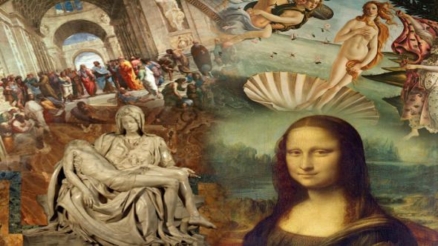
Answer the question or define the term for each:

Renaissance and Discovery

The Renaissance in Italy
People to Know
- Petrarach (1304-1374)
- Cosimo de’ Medici (1389-1464)
- Lorenzo de’ Medici (r. 1478-1492)
- Petrarach (1304-1374)
- Giotto (1266-1336)
- Leonardo da Vinci (1452)
- Raphael (1483-1520)
- Michelangelo (1475-1564)
- Charles VIII (r.1483-1498)
- Pope Alexander VI (r. 1492-1503)
- Niccolò Machiavelli (1469-1527)
- What characterized Renaissance Europe after the 14th century?

- What attributed to the abrupt end of the Renaissance in Italy?

The Italian City-State
- What allowed the Italian city-state to be the “bankers for much of Europe”?

- How did the Italian city-states differ from cities in norther Europe?

- Briefly describe the four different social groups within the city of Florence:

Terms to Know
- Renaissance
- humanism
- studia humanitatis
- civic humanism
- laity
- linear perspective
- mannerism
- Machiavellian

- Describe the role of despotism in the Italian city-states.

- Describe the governments of Florence, Milan, and Venice. What makes Venice different from the rest?

Humanism
- What is humanism? (not easily answered)

- What sources did humanist draw inspiration and knowledge from?

- What was the goal of a humanist study?

- Which ancient Greek has perhaps the most influence on humanism in the Italian Renaissance?

- What was Lorenzo Valla unintentionally critical in his works? *

- Describe the two sides of humanism:
deep scholarship –

practical politics (later in chapter) –

Key Events
1375-1527 – Italian Renaissance
1434 – Medici begin rule in Florence
1494 – 1st French (Charles VIII) invasion of Italy
1495 – League of Venice established
1499 – 2nd French (Louis XII) invasion of Italy
1512-13 – Holy League defeats French
1513 – Machiavelli writes The Prince
1516 – Concordat of Bologna
1527 – Rome raided by Spanish

Renaissance Art
- What are the characteristics of Renaissance art?

- What are three devotional aspects of Renaissance art found in Michelangelo’s work?

Slavery in the Renaissance
- Who were used as slaves in the early western slave markets of the 12th century?

- What event helped to account for the increase in slavery found during the Renaissance?

- How were Renaissance slaves treated?

Italy’s Political Decline: The French Invasions
- How did France become involved in Italian affairs?

Charles VIII’s March Through Italy
- How did Spain become involved in Italian affairs?

Pope Alexander VI and the Borgia Family
- Explain the corruption and ambition of Pope Alexander VI.

Pope Julius II
- How was Pope Julius able to fulfill papal goals of securing the Papal States?

Niccolò Machiavelli
- What does the term “Machiavellian” mean?

- Describe the political beliefs held by Machiavelli:

Ends –

Unity –

Ruthlessness –

