Unit II – Rebirth and Exploration
(2-4) The Transatlantic Economy – pg. 272 – 290
Guided Reading Questions
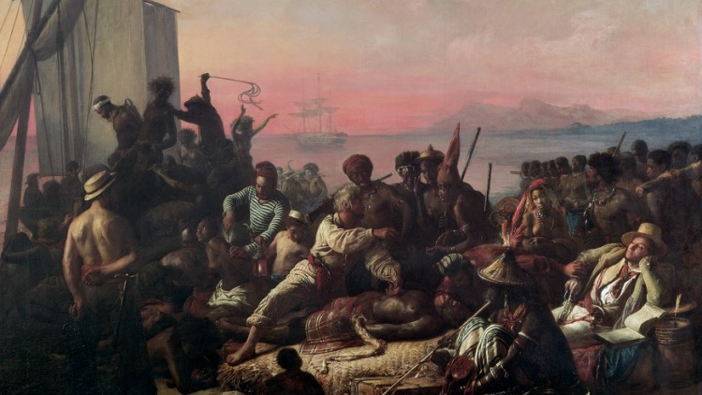
Answer the question or define the term for each:

Transatlantic Economy

Periods of European Overseas Empires
- Briefly describe and give the characteristics of each of the four stages of European contact with the rest of the world:
People to Know
- Philip V (r. 1700-1746)
- Charles III (r. 1759-1788)
Stage 1 –

Stage 2 –

Stage 3 –
Terms to Know
- mercantilism
- viceroy
- peninsulares
- creoles
Stage 4 –

- What allowed Europeans to exercise their influence and their will over the rest of the world?

Mercantile Empires
- List the major areas of control for each of the major colonial powers:
Spain –
Key Events
1492-1600 – Stage 1 of European-World contact
1600-1820 – Stage 2 of European-World contact
1820-1950 – Stage 3 of European World contact
1950~ – Stage 4 of European-World contact

Britian –

France –

Netherlands –

Mercantilist Goals –
- Under mercantilist thinking, how does a nation gain wealth?

- Why has the 18th century be labeled by some as the “golden age of smugglers”?

French-British Rivalry
- What area of the Americas was the most highly sought after and why?

- What allowed France and Britain to exercise more influence and control over India?

The Spanish Colonial System
Colonial Government
- How would you describe the governmental structure of the Spanish colonial government?

Trade Regulations
- Describe the flota system?

- What impact did the reforms of Charles III have on the Spanish mercantile system?

Black African Slavery, The Plantation System, and the Atlantic Economy
- What caused the Portuguese to seek African slaves?

The African Presence in the Americas
- What was the source of the slave in the slave markets that populated the west African coast?

- Where were the majority of slaves imported?

- Looking at Map 16-2, What is interesting to note about the nation of France as opposed to the other major nations of Europe?

- What accounts for the increase in slave trading that occurred during the 17th century?

Slavery and the Transatlantic economy
- Describe the geographical trade system between Europe, African and the Americas.

The Experience of Slavery
- Although disputed, how many African slaves were transported to the Americas?

- Describe the process of “seasoning” a slave.

- What did eventually having a shared language allow the African slaves to do?

- How was the life and welfare of a slave viewed?*

- What is important about the following dates as they relate to slavery:
1794 –

1807 –

1863 –

1888 –

