Unit IV – A Question of Sovereignty
(4-1) English Civil War and Glorious Revolution – pg. 168 – 179
Guided Reading Questions
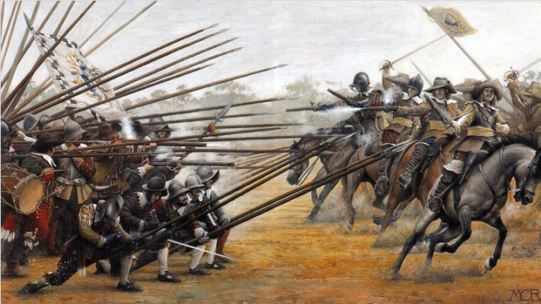
Answer the question or define the term for each:

European State Consolidation in the Seventeenth and Eighteenth Centuries
- How long has Europe dominated other parts of the world?

- What power-shift occurred within Europe during the seventeenth and eighteenth centuries?

- Name the five major states that dominated European politics during this time period and beyond?
People to Know
- William of Orange (1650-1702)
- James VI/I (Eng. r. 1604- 1624)
- Charles I (r. 1625-1649)
- Oliver Cromwell (1599-1658)
- Charles II (r. 1660-1685)
- James II (r. 1685-1688)
- William and Mary (r. 1689-1702)
- Robert Walpole (1676-1745)

The Netherlands: Golden Age of Decline
- How could it be said that the Netherlands were ahead of the time both politically and religiously?

Urban Prosperity
- What factors help explain how the Dutch made the Netherlands so prosperous?
Terms to Know
- parliamentary monarchy
- absolutism
- divine right of kings
- Puritans
- Cavaliers
- Roundheads
- Glorious Revolution

Economic Decline
- What role did banking play in keeping the Netherlands from becoming insignificant?

Two Models of European Political Development
- Which nation best models the following political types of European monarchies?
parliamentary monarchy –

absolute monarchy –

Constitutional Crisis and Settlement in Stuart England
James I
Key Events
1620 – Puritans found Plymouth colony
1628 – Petition of Right signed
1642-1646 – English Civil War
1670 – Treaty of Dover
1678-1681 – Popish Plot
1688 – Glorious Revolution
1689 – William and Mary become joint rulers
1689 – English Bill of Rights passed
1707 – Act of Union united England and Scotland

- Why did some question James’s religious affiliation?

Charles I
- Describe the disputes of Charles I prior to the outbreak of war.
with Parliament –

with Scotland –

The Long Parliament and Civil War
- How did Parliament’s distrust of Charles I lead to the outbreak of the English Civil War?

Oliver Cromwell and the Puritan Republic
- How did the rule of Oliver Cromwell change AND unify England?
leadership/king –
role of Parliament –
religion –
other –
Charles II and the Restoration of the Monarchy
- How could the first decade of Charles II’s reign be seen as a “return to normalcy”?

- How did the Treaty of Dover (1670) and the Test Act (1673) lead to further conflict in England resulting in the Popish Plot from 1678-1681?

The “Glorious Revolution”
- By the reign of James II, the fourth king in the line of Stuart kings, what seems to be a reoccurring trend among kings in relation to Parliament?

- How did James II lose his throne?

- How might the English Bill of Rights and the Toleration Act (1689) be seen as hypocritical?

The Age of Walpole

