Unit V – A Shifting Society
(5-1) The Enlightenment – pg. 311 – 336
Guided Reading Questions
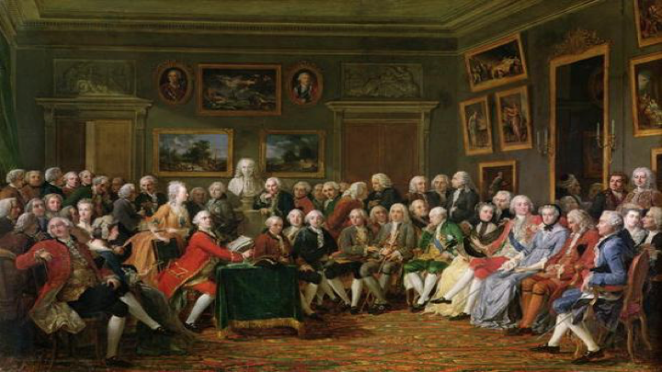
Answer the question or define the term for each:

The Age of Enlightenment: Eighteenth-Century Thought
People to Know
- Baron de Montesquieu (1689-1755)
- Voltaire (1694-1778)
- Denis Diderot (1713-1784)
- Immanuel Kant (1724-1804)
- Adam Smith (1723-1790)
- Describe the Enlightenment*.

Formative Influences on the Enlightenment
- How did Isaac Newton influence Enlightenment thought?

- How was England seen as the “poster-child” for the Enlightenment?
Terms to Know
- Enlightenment
- philosophes
- deism
- physiocrats
- laissez-faire

The Emergence of a Print Culture
- What influence had printing had on European society by the 18th century?

The Philosophes
- Explain the role and purpose of the philosophes?

Key Events
1748 – Spirit of Laws published
1751-72 – Encyclopedia published
1762 – The Social Contact published
1776 – Wealth of Nations published

- What common bond united the philosophes together?

Philosophes and Patrons
- What impact did Voltaire have on European society*?

The Enlightenment and Religion
- Why did the philosophes clash with religious institutions?

- What roles did the church play in many parts of Protestant and Catholic society?

Deism
- Explain the two major points of deism?

Toleration
- Describe the views of toleration by the following proponents:
Voltaire –

Gotthold Lessing –

John Toland –

Mary Wortley Montagu –

Radical Enlightenment Criticism of Christianity
The Limits of Toleration

The Jewish Enlightenment
- How did Moses Mendelssohn impact the Jewish faith during the Enlightenment?

The Enlightenment and Society
The Encyclopedia: Freedom and Economic Improvement
- What purpose did the Encyclopedia have on learning in the 18th century?

Beccaria and Reform of Criminal Law
The Physiocrats and Economic Freedom
Adam Smith on Economic Growth and Social Progress
- How did Adam Smith believe economies growth could best be achieved?

- Describe Smith’s four-stage theory?

Political Thought of the Philosophes
Montesquieu and Spirit of the Laws
- How did Montesquieu contribute and influence the social sciences?

Rousseau: A Radical Critique of Modern Society
- Explain Rousseau’s social contract and the relationship between individuals and society?

- How did Rousseau challenge the thinkers of the Enlightenment and importance of a society to the individual and his wealth?

Enlightenment Critics of European Empires
- List the ideas held by critics of European Empires

Women in Thought and Practice of the Enlightenment
- What role did women play in advancing the Enlightenment?

- How were women view during the 18th century?

