Unit V – A Shifting Society
(5-2) Enlightened Absolutism – pg. 339 – 351
Guided Reading Questions
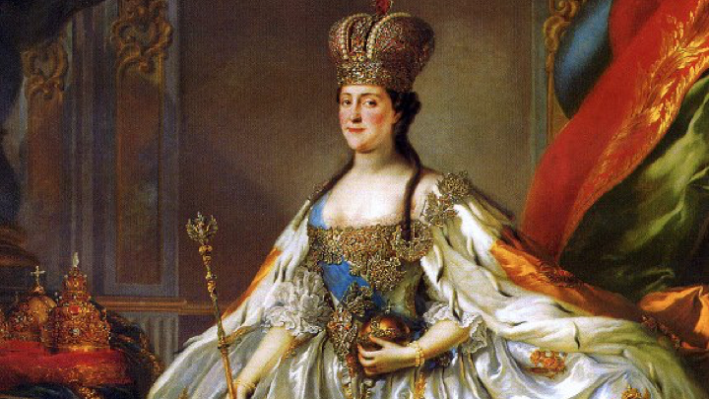
Answer the question or define the term for each:

Enlightened Absolutism
People to Know
- Frederick the Great (r. 1740-1786)
- Catherine the Great (r. 1762-1796)
- Joseph II (r. 1765-1790)

- How did Frederick the Great, Joseph II, and Catherine the Great differ from other absolute monarchs who had come before?

Frederick the Great of Prussia
- How did Frederick II’s policy of merit-based promotions influence the Prussian state?

- While showing unprecedented religious tolerance, how might one argue that Frederick II’s toleration had limits?
Terms to Know
- enlightened absolutism

- How did Frederick II use the state to help improved the lives of his subjects?

Joseph II of Austria
- How did Joseph II and his mother, Maria Theresa, increase the power of the central government authority?

- How did Joseph II approach religious toleration? Did that toleration extend fully to his own Catholic Church?

Catherine the Great of Russia
- How was Catherine able to maintain her absolute monarchy’s power?

Key Events
1740-86 – reign of Frederick the Great
1762-96 – reign of Catherine the Great
1765-90 – reign of Joseph II

- What was the drive behind Russia’s territorial expansion?

The Partitions of Poland
- How was Poland partitioned/divided up among the three great powers?
Russia –

Prussia –

Austria –

The End of the Eighteenth Century in Central and Eastern Europe

Please read the “IN PERSPECTIVE” section for an overview of the chapter.

