Unit V – A Shifting Society
(5-4) Revolutions in Agriculture and Industry – pg. 249 – 271
Guided Reading Questions
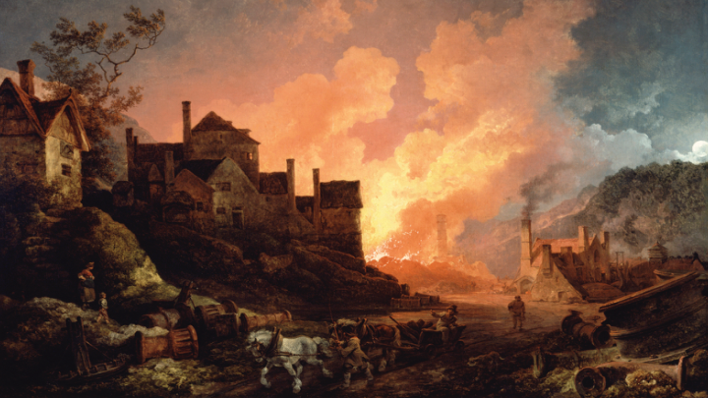
Answer the question or define the term for each:

The Revolution in Agriculture
People to Know
- James Watt (1736-1819)

- Describe how poor harvest or increasing food prices impacted European society during the 18th century?

New Crops and New Methods
- Describe the impact of these men on agriculture:

Jethro Tull –
Terms to Know
- Agricultural Revolution
- enclosures
- Industrial Revolution
- consumer revolution
- cottage industry/putting-out system
- flying shuttle
- spinning jenny
- ghetto

Charles Townsend –

Robert Bakewell –

- How did enclosures help to facilitate a more capitalistic agricultural system?*

Expansion of the Population
- How did the increase in population help to spur the Agricultural and Industrial Revolutions?

- What factors help to contribute to the increase in population?

The Industrial Revolution of the Eighteenth Century
Key Events
1733 – flying shuttle invented
1765 – spinning jenny invented
1769 – water frame invented
1769 – steam engine perfected

.

A Revolution of Consumption
- How did the increase of consumption impact the Industrial Revolution?*

Industrial Leadership of Great Britain
- What factors contributed to Great Britain being the first to pioneer the Industrial Revolution?

New Methods of Textile Production
- Explain how the following inventions solved the problems of industrial “bottle necks” that arose in production of textiles.
spinning jenny –

water frame –

The Steam Engine
- What were the benefits of steam power over other forms of power available at the time?

Iron Production
- How was Britain able to overcome the factors that limited iron production?

The Impact of the Agricultural and Industrial Revolution on Working Women
- How did industrialization and mechanization impact women?

- Explain the long-term results of the shift in female employment.

The Growth of Cities
Patterns of Preindustrial Urbanization
- Describe the growth of cities in the 18th century.

- What explains the rise of population in both capital and port cities?

Urban Classes
- Briefly describe each of the following classes:
upper class –

middle class/bourgeoisie –

artisans –

- How did the rise of the middle class create conflict with the upper class?

The Urban Riot
- How was the riot used as a political tool?

The Jewish Population: The Age of the Ghetto
- Briefly describe the treatment of Jewish in Europe during the 18th century?

Please read the “IN PERSPECTIVE” section for an overview of the chapter.

