Unit VI – Revolution
(6-1) The French Revolution – pg. 353 – 373
Guided Reading Questions
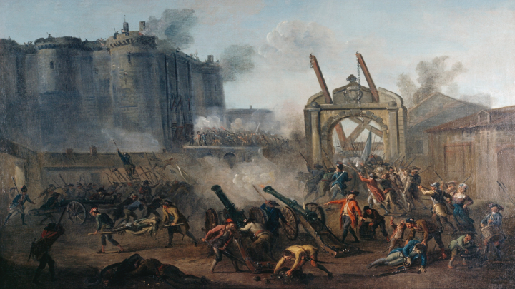
Answer the question or define the term for each:

The French Revolution
People to Know
- Jacques Necker (1732-1804)
- Louis XVI (r. 1774-1792)
- Marie Antoinette (1755-1793)

The Crisis of the French Monarchy
- What was the original cause of the troubles in France?

The Monarchy Seeks New Taxes
- How were peasants hit hardest by the financial troubles of France?

- How did Louis XVI’s attempt to regain popular support hurt the financial reforms that might have solved France’s financial problems?

- How did Louis XVI’s public image leave him unable to rally public opinion in support of reform?

Necker’s Report
- How did Necker’s miscalculations make it more difficult to fix France’s financial problems?
Terms to Know
- Estates General
- 1st Estate
- 2nd Estate
- 3rd Estate
- Tennis Court Oath
- “Great Fear”
- Declaration of the Rights of Man and Citizen
- émigrés

Calonne’s Reform Plan and the Assembly of Notables
- What role did the nobility play in ensuring royal reforms were not carried out?*

Deadlock and the Calling of the Estates General
The Revolution of 1789
The Estates General Becomes the National Assembly
- Why did the Third Estate distrust the composition and functioning of the Estates General?

- How were the problems of the Estates General solved with the forming of the National Assembly and the Tennis Court Oath?*

Fall of the Bastille
Key Events
1787 – the Assembly of Notables meet
1789
May – meeting of the Estates General
Jun – 3rd Estate forms the National Assembly
Jul – Tennis Court Oath is taken
Jul – Storming of the Bastille
Aug – the “Great Fear” strikes France
Aug – the Declaration of the Rights of Man and Citizen published
Oct – Parisian women march on Versailles
1791 – National Assembly est. Constitutional Monarchy
1791 – Louis XVI attempts to flee Paris
1791 – Declaration of Pillnitz issued

- How did the mustering of royal troops at Versailles and in Paris help lead to the Storming of the Bastille?

- How did the tricolor flag of revolutionary France come about?

- In what ways did Louis XVI concede defeat to the people of Paris?

The “Great Fear” and the Night of August 4
- What effect did the night of August 4 have on French society?

The Declaration of the Rights of Man and Citizen
- How can the Declaration of the Rights of Man and Citizen be seen as an Enlightened document?

- Why would women be concerned with the Declaration of the Rights of Man and Citizen and other events taking place during the Revolution?

The Parisian Women’s March on Versailles
The Reconstruction of France
Political Reorganization
- How had power been transferred by the new French Constitution?

- How had women been affected by the Revolution and the new French Constitution?

Economic Policy
- How did the National Assembly’s economic policy impact each of the following:
  - Workers’ Organizations –

  - The Church –

  - The Assignats –

The Civil Constitution of the Clergy
- How was the Civil Constitution of the Clergy and major blunder for the National Assembly leading to even greater division within France?

Counterrevolutionary Activity
- How did Louis XVI’s flight to Varennes endanger the constitutional monarchy?

- How was the Declaration of Pillnitz viewed by the revolutionaries in France?

