Unit VI – Revolution
(6-4) Romanticism – pg. 414 – 427
Guided Reading Questions
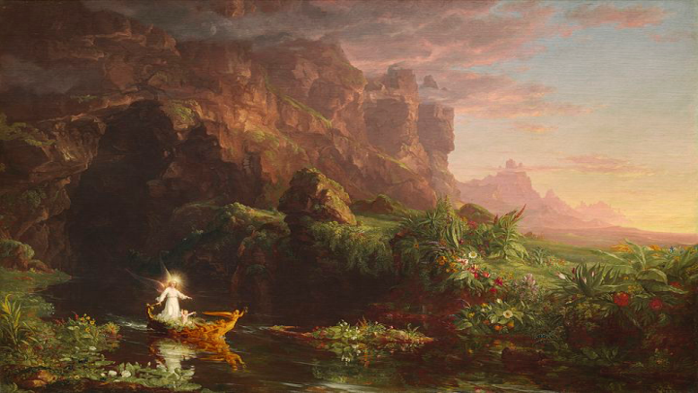
Answer the question or define the term for each:

The Romantic Movement
People to Know
- John Wesley (1703-1791)
- Jean-Jacques Rousseau (1712-1778)
- Immanuel Kant (1724-1804)

- Describe a Romantic? What are their passions/interests?

Romantic Questioning of the Supremacy of Reason

Rousseau and Education
- Explain Rousseau’s view on education.

Kant and Reason
Terms to Know
- Romanticism
- categorical imperative
- Methodism

- How does Kant bridge the divide between the Enlightenment and Rousseau?

- Explain Kant’s “noumenal world”.

Romantic Literature
English Romantic Writers
- What notable works did the following authors write during the Romantic period?
- Lord Byron –
- Mary Shelley –

The German Romantic Writers
Romantic Art
The Cult of the Middle Ages and Neo-Gothicism
- Explain why the British House of Parliament looks the way it does?

Nature and the Sublime
Religion in the Romantic Period
Methodism
- Explain the concept of Methodism.

Key Events

New Directions in Continental Religion
- How did Friedrich Schleiermacher view Christianity and other world religions?

Romantic Views of Nationalism and History
Herder and Culture
- According to Herder’s view of the world, what was of extreme importance?

Hegel and History
- Explain Hegel’s view of history and the thesis, antithesis, and synthesis.

Islam, the Middle East, and Romanticism
- How did Romantics view Islam? The Crusades?

Please read the “IN PERSPECTIVE” section for an overview of the chapter.

