Unit I – The Rise of Europe
(1-2) Avignon Papacy and Great Schism – pg. 46 – 58
Guided Reading Questions
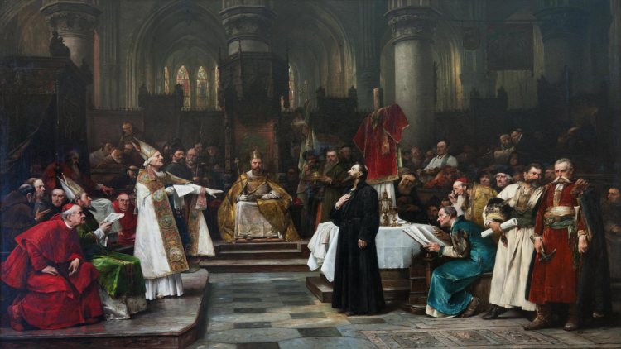
Answer the question or define the term for each:

Ecclesiastical Breakdown and Revival: The Late Medieval Church

The Thirteenth-Century Papacy
People to Know
- Pope Innocent III (r.1198-1216)
- Pope Boniface VIII (r.1294-1303)
- King Philip IV (r.1285-1314)
- Pope Clement V (r.1305-1314)
- John Wycliffe (1330-1384)
- John Huss (1369-1415)
- Pope Urban VI (r.1378-1389)
- Pope Clement VII (r.1378-1397)
- What impact did Pope Innocent III have on the church both political and spiritually?

- In what way was political influence becoming a problem for the Church (you need to understand the role of the College of Cardinals)

- How did Pope Boniface VIII become the pope?

Boniface VIII and Philip the Fair
- Why did Pope Boniface VIII’s issue the papal bull, Clericis laicos, and what was the response by both England and France?

- What was King Philip IV attempting to do when he arrested and tried the pope’s legate, Bernard Saisset?

- What was King Philip IV’s response to the Unam Sanctam?
Terms to Know
- ecclesiastical
- Rota Romana
- College of Cardinals
- Unam Sanctam
- purgatory
- indulgence
- Lollards
- Hussites
- transubstantiation**
- “Babylonian Capitivity”
- conciliar theory

- How could it be seen that the papacy was bowing down to the Philip IV and the French state under the papacy of Clement V?

- What is the overall effect that Pope Boniface’s conflict with Philip IV had on the relationship between church and state?

The Avignon Papacy (1309-1377)
- Briefly explain the concept of indulgences and their relationship to purgatory.

- What argument is Marsilius of Padua making in his work, Defender of Peace (1324)?

- Why might non-French Christians be concerned with the papacy in Avignon, especially under Pope Clement Vi?

Key Events
1243-1480 – Mongol rule of Russia
1302 –Unam Sanctam issued
1309-1377 – Avignon Papacy (“Babylonian Captivity”)
1378-1417 – The Great Schism
1410 – Council of Pisa ends
1417 – Council of Constance ends
John Wycliffe and John Huss
- Briefly describe the beliefs of John Wycliffe.

- How did Lollards practice their faith?

- Briefly describe the beliefs of Czech reformers like John Huss.

- What was the fate of John Huss?

The Great Schism (1378-1417) and the Conciliar Movement to 1449
- Why was a second conclave called to vote for new pope?:
Given reason –

Real reason –

- What was the result of each of the following councils?:
Council of Pisa (1409-1410) –

Council of Constance (1414-1417) –

Council of Basel (1431-1449) –

Medieval Russia
- What impact did Prince Vladimir of Kiev have on the Russian religion?

Politics and Society
Mongol Rule (1243-1480)
- What locations did the Mongol/Tatar armies conquer?

- What name was given to the Russian portion of the Mongol Empire?

- What became the “third Rome” and what is its importance to Russia?

Please read the “IN PERSPECTIVE” section for an overview of the chapter.

