Unit XI – Global Conflicts
(11-3) World War II – pg. 743–767
Guided Reading Questions
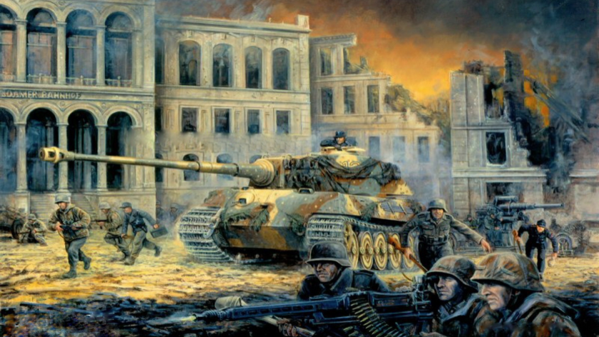
Answer the question or define the term for each:
People to Know
- Francisco Franco (1892-1975)
- Neville Chamberlain (1869-1940)
- Winston Churchill (1874-1965)
- Franklin D. Roosevelt (1882-1945)
- Hideki Tojo (1885-1948)
- Dwight D. Eisenhower (1890-1969)
- Harry Truman (1884-1972)
Terms to Know
- Lebensraum
- appeasement
- Sudetenland
- Munich Pact
- blitzkrieg
- Maginot Line
- Luftwaffe
- RAF
- Operation Barbarossa
- Battle of Stalingrad
- D-Day

World War II

Again the Road to War (1933-1939)
- To Hitler and the Nazi Party (and many other Germans) what was the source of all their problems?

Hitler’s Goals
- What was Hitler’s ultimate goal?

- What was Hitler’s justification for rearming Germany?
Key Events
1931 – Japan invades Manchuria
1933 – Germany leave the League of Nations
1935
Mar -Hitler begins to rearm Germany
Oct – Italy invades Ethiopia
1936 – Rome-Berlin Axis formed
1936-1939 – Spanish Civil War
1938
Mar – Germany annexes Austria
Sept – Munich Conference turns over the Sudetenland
1939
Mar – Germany occupies Czech state
Aug – Nazi-Soviet pact
Sept – Germany invades Poland/WWII begins
1940
Apr – Germany invades Denmark & Norway
May – Germany invades the Low Countries
Jun – Germany invades France
Aug/Sept – Battle of Britain
1941
Jun – Germany invades the Soviet Union/Operation Barbarossa
Dec – Japanese attack Pearl Harbor
1942
Jun – Battle of Midway
Nov/Feb – Battle of Stalingrad
1943 – Allied invasion of Italy
1944
Jun – Battle of Normandy/D-Day
Sept – France liberated
Dec – Battle of the Bulge
1945
May – German surrenders
Aug – atomic bombs dropped/Japan surrenders

- Why did the League of Nations fail?

Italy Attacks Ethiopia
- How was the League of Nations impotent in dealing with Mussolini?

Remilitarization of the Rhineland
- Why were the former Allies so reluctant to take action against Hitler in the Rhineland?

The Spanish Civil War
- Besides all being fascist and helping build alliances, why might Italy and Germany be eager to support Franco in the Spanish Civil War?**

Austria and Czechoslovakia
- How was Hitler able to acquire Austria?

- Why was Hitler so interested in Czechoslovakia?

Munich
- How was the Munich Pact a failure of appeasement?

- Why did Hitler’s actions in Prague end the illusion that Hitler only wanted to united Germans?

- What is the lesson of Munich?

- Why would a West-Russian alliance have been difficult to achieve?

The Nazi-Soviet Pact
- Why was the Nazi-Soviet pact so unusual?

World War II (1939-1945)
The German Conquest of Europe
- Describe blitzkrieg tactics.

- How was the German advance on the Western Front of World War II similar to that of World War I? How was it different?
similar –

different –

The Battle of Britain
- Why did Germany loose the Battle of Britain?

The German Attack on Russia
- How did Mussolini’s vanity cost Hitler a possible victory in Russia?

- Why did Germany fail in Operation Barbarossa despite massive success initially?

Hitler’s Plans for Europe
- What were Hitler’s plans for Europe?

Japan and the United States Enter the War
- Why did the Japanese Empire attack the United States?**

The Tide Turns
- What major turning points happened in each region?
Pacific –

Africa –

Europe –

long-range fighter planes –

The Defeat of Nazi Germany
Fall of the Japanese Empire
- What are the reasons (plural) for the U.S. use of the atomic bombs on Japan?

The Cost of War

