Unit XI – Global Conflicts
(11-4) The Scars of the War – pg. 767–784
Guided Reading Questions
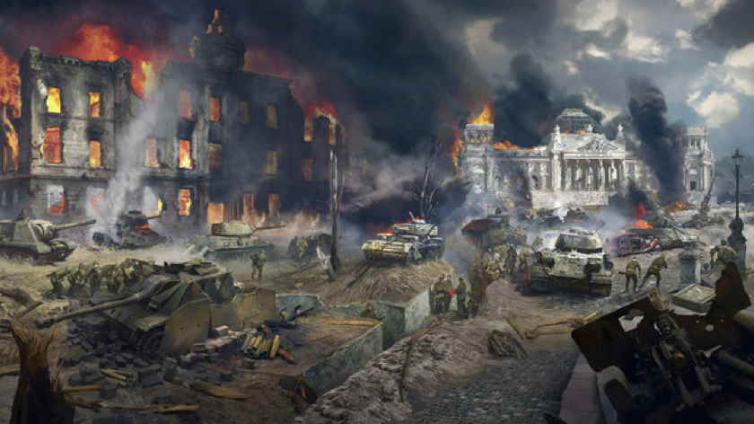
Answer the question or define the term for each:
People to Know
- Josef Goebbels (1897-1945)

Racism and the Holocaust
- What were Hitler and Himmler’s plan for eastern Europe?

- Taken as a whole, where did the most devastating destruction of Jewish communities take place?

The Destruction of the Polish Jewish Community
- Why were Jews easy targets in Poland?

Polish Anti-Semitism Between the Wars
- What anti-Semitic actions were taken by Poland prior to World War II?
Terms to Know
- Holocaust
- ghettos
- pseudoscience
- Vichy France
- Atlantic Charter
- Tehran Conference
- Potsdam Conference

The Nazi Assault on the Jews of Poland
- Why was Poland so important to the Nazis assault on Jews?

- What was the purpose of the ghettos?*

- Prior to the use of death camps, how did Nazis exterminate Jews?

- Where the Nazis virtually able to achieve their goal of ridding Poland of Jews?

Explanations of the Holocaust
- Why were the Jews the main target of Hitler’s policy of extermination?

Key Events
1941 – agreement of the Atlantic Charter
1942-1945 – Jew sent to concentration camps
1943 – Tehran Conference
1945
Feb – Yalta Conference
July – Potsdam Conference

- How was it possible to carry out such a vast mass murder?

- What other atrocities were carried out by non-German participates of World War II?
Soviets –

British/Americans –

America –

The Domestic Fronts

Germany: From Apparent Victory to Defeat
- What changed Germany to a full wartime footing?

- How were women view on the home front?

- What about the war transformed Germany the most?

France: Defeat, Collaboration, and Resistance
- Describe Vichy France.

- Why did so few Frenchmen join the Resistance prior to 1944?

Great Britain: Organization for Victory
- What was possibly the worst experience by the British on the home front?

- What impact did radio have on the home front and the war itself?

The Soviet Union: “The Great Patriotic War”
- How did Stalin’s prewar activities make the Soviet Union well prepare for wartime?

- What limited the Russian army?

- How was Soviet propaganda different that other nations?

- Why was Stalin so willing to support partisan forces?

Preparations for Peace
The Atlantic Charter
- How did Mussolini’s vanity cost Hitler a possible victory in Russia?

Tehran: Agreement on a Second Front
- What major decision was made at the Tehran Conference? What was the effect of this?

- What demands were made of Stalin and the Soviet Union?

Yalta
Potsdam
- What happened to Poland and Germany as a result of the Potsdam Conference?

Please read the “IN PERSPECTIVE” section for an overview of the chapter.

