Unit XII – The Long Peace
(12-1) Origins of the Cold War – pg. 786 –803
Guided Reading Questions
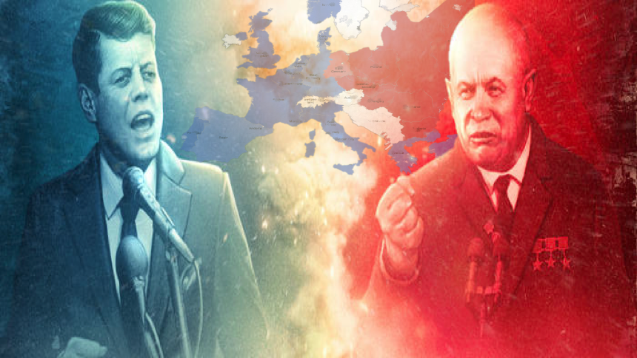
Answer the question or define the term for each:

The Cold War Era, Decolonization, and the Emergence of a New Europe
People to Know
- Joseph Stalin (1879-1953)
- Harry Truman (1884-1972)
- Nikita Khrushchev (1984-1971)
- John F. Kennedy (1917-1963)
- Leonid Brezhnev (1906-1982)

The Emergence of the Cold War
- What were the supposed causeS (plural) of the Cold War?

- How did Britain “pass the torch” to the United States?

- What did the United States and the Soviet Union believe each nation was trying to do to the other?
Terms to Know
- Cold War
- iron curtain
- containment
- Truman Doctrine
- Marshall Plan
- Cominform
- Berlin Blockade/Airlift
- NATO/Warsaw Pact
- Sputnik
- Berlin Wall
- Brezhnev Doctrine
- détente

American fears –

Soviet fears –

Containment in American Foreign Policy
- What were the four major consequence of the U.S. policy of containment?

- Why did the United States enact the Marshall Plan?
Key Events
1945-1991 – The Cold War
1946 – Iron Curtain descends
1947 – Truman Doctrine est.
1947 – Marshall Plan enacted
1948 – Berlin Airlift
1948 – Israel is created
1949 – NATO is created
1950-1953 – Korean War
1953 – Stalin dies
1955 – Warsaw Pact is created
1956
Feb – Khrushchev become leader of Soviet Union
Oct – Suez Crisis
1957 – Sputnik is launched
1961 – Berlin Wall is constructed
1962 – Cuban Missile Crisis
1968 – Soviet invasion of Czechoslovakia
1979 – Soviet invasion of Afghanistan

Soviet Domination of Eastern Europe
- How did Stalin and the Soviet Union dominated Eastern Europe?

- What made communism in Yugoslavia unique?

The Postwar Division of Germany
- How did disagreements over Germany lead to the Berlin Blockade?

NATO and the Warsaw Pact
- What impact did the creation of NATO have on the United States AND Europe?

The Creation of the State of Israel
- Why were Europeans interested in creating a Jewish state AND why were still interested in the state after its creation?

The Korean War
The Khrushchev Era in the Soviet Union
Khrushchev’s Domestic Policies
- How was Khrushchev’s leadership style different than Stalin’s?

- How did Khrushchev’s policies mark a dramatic shift in Soviet policy beginning in 1956?

The Three Crisis of 1956
- What two realizations came from the Suez Intervention?

- What is geopolitically demonstrated by the actions of the Soviet Union in Hungary?

Later Cold War Confrontations
The Berlin Wall
The Cuban Missile Crisis
- What was the lasting results of the Cuban Missile Crisis on the Soviet Union?

The Brezhnev Era
1968: The Invasion of Czechoslovakia
- How are the Brezhnev Doctrine and the Truman Doctrine similar? How are they different

The United States and Détente
- Explain how the U.S. policy of détente emboldened the Soviet Union*?

The Invasion of Afghanistan
- Why would the term “Soviet’s Vietnam” be appropriate in describing the Soviet’s invasion of Afghanistan?

Communism and Solidarity in Poland
Relations with the Reagan Administration
- How was the U.S. proposed “Star Wars” program an example of economic warfare being used against the Soviet Union?

