Unit III – A Fractured Faith
(3-1) The Reformation – pg. 97 – 117
Guided Reading Questions
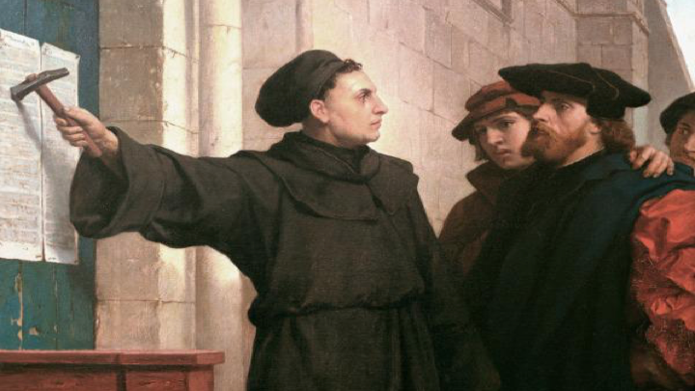
Answer the question or define the term for each:

The Age of Reformation
- How did the Renaissance impact the Reformation?

Society and Religion
People to Know
- Martin Luther (1483-1546)
- Emperor Charles V (r.1519-1556)
- Ulrich Zwingli (1484-1531)
- John Calvin (1509-1564)

Social and Political Conflict
- How did the Reformation appeal to guilds, townsfolk and peasants?

Popular Religious Movements and Criticism of the Church
- What type of church were earlier reformers looking to create through reform?
Terms to Know
- Reformation
- purgatory
- indulgences
- “justification by faith”
- transubstantiation*
- Anabaptists
- predestination
- Briefly describe the complaints made against these church practices:
benefice system –

indulgences –

clerical privilege –

Martin Luther and the German Reformation to 1525
- Briefly describe Luther’s beliefs on the following topics:
Key Events
1510 – Luther travels to Rome
1517 – Luther posts the Ninety-Five Theses
1519 – Zwingli becomes priest in Zurich
1521 – Diet of Worms
1524-25 – Peasants’ Revolt
1530 – Diet of Augsburg
1534-35 – Anabaptist conduct Munster Rebellion
1540 – John Calvin returns ministry to Geneva
1555 – The Peace of Augsburg

trip to Rome in 1510 –

“justification by faith” –

good works –

The Attack on Indulgences
- How did the concept of an indulgence come to be under Pope Clement VI?

- What problem did Martin Luther have against John Tetzel and what was his (Luther’s) response?

Election of Charles V
- How did the election of Charles V benefit the Reformation?

Luther’s Excommunication and the Diet of Worms
- Briefly describe the relevance of Luther’s three famous pamphlets:
Address to the Christian Nobility of the German Nation –

Babylonian Captivity of the Church –

Freedom of a Christian –

Imperial Distractions: War with France and the Turks
- How did the wars with France and the Turks contribute to the Reformation’s hold in the German states?*
*(outside reading may be needed)

How the Reformation Spread
The Peasants’ Revolt
- Why were the peasants revolting and why would they believe to find Luther an ally in their cause?

- Why would Luther denounce the peasant’s revolt against the German princes?

The Reformation Elsewhere
Zwingli and the Swiss Reformation
- Briefly describe the two reforms of Ulrich Zwingli:

Anabaptists and Radical Protestants
- Why would Anabaptists be seen as a threat to religious AND political authorities?
religious –

political –

John Calvin and the Genevan Reformation
- What impact did John Calvin have on the Protestant Reformation?

Political Consolidation of Lutheran Reformation
The Diet of Augsburg
- What was the emperor’s solution to the political division in the Diet of Augsburg?

The Expansion of the Reformation
- What evidence is there of the spread of Protestantism in the early 16th century?

Reaction Against Protestants
The Peace of Augsburg
- What effect did the Peace of Augsburg have on the establishment of Protestantism in the German states?

