Unit III – A Fractured Faith
(3-2) The English Reformation – pg. 117 – 133
Guided Reading Questions
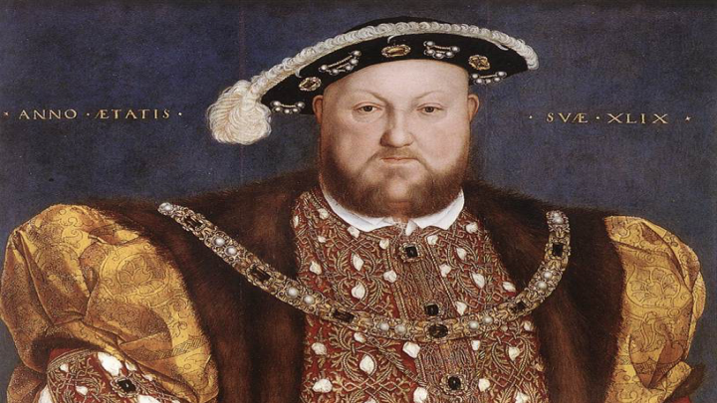
Answer the question or define the term for each:

The English Reformation to 1553

The Preconditions of Reform
People to Know
- William Tyndale (1492-1536)
- Cardinal Thomas Wolsey (1475-1530)
- Sir Thomas More (1478-1535)
- Henry VIII (r.1509-1547)
- Catherine of Aragon (1485-1536)
- Thomas Cromwell (1485-1540)
- Thomas Cranmer (1489-1556)
- Ignatius of Loyola (1491-1556)
- Miguel de Cervantes Saavedra (1547-1616)
- William Shakespeare (1564-1616)

The King’s Affair
- Why did Henry VIII’s marriage to Catherine of Aragon cause him trouble?

- What became Henry VIII’s solution to his inability to annul his first marriage?

The “Reformation Parliament”
- List the major events that took place during the following years:
1531 –
1532 –

1533 –
Terms to Know
- Act of Supremacy
- Jesuits
- wet nurse

1534 –

Wives of Henry VIII
- What became the fate of Henry VIII’s 6 wives?
Catherine of Aragon –
Anne Boleyn –
Jane Seymour –
Key Events
1533 – Henry VIII marries Anne Boleyn
1534 – Acts of Succession and Supremacy passed
1545-1563 – Council of Trent
1590-1610 – Shakespeare’s works are written

Anne of Cleves –
Catherine Howard –
Catherine Parr –

The King’s Religious Conservatism
- How Protestant did England become under Henry VIII?

The Protestant Reformation under Edward VI
- How different was the Protestant Reformation under Edward VI from his father’s?

Catholic Reform and Counter-Reformation
Sources of Catholic Reform
Ignatius of Loyola and the Jesuits
- What was the purpose of the Jesuits?

The Council of Trent (1545-1563)
- What was the outcome of the Council of Trent? Was the Protestant Reformation’s presence evident in the council’s decisions?

The Social Significance of the Reformation in Western Europe
The Reformation in Religious Practices and Institutions
- Describe the differences between religious life in the fifteenth century as compared to religious life in the sixteenth century.

The Reformation and Education
- What impact did humanism have on education during the Protestant Reformation?

The Reformation and the Changing Role of Women
- How did the role of women change during the Protestant Reformation?

Family Life in Early Modern Europe
Later Marriages
- Why did Europeans wait longer to engage in marriage? What impacts did this have on women?

Arranged Marriages
- Were arranged marriages forced upon unwilling children?

Family Size
- What factor may have accounted for the larger size of family households?

Birth Control
Wet Nursing
- What was the purpose of a wet nurse? Why would upper-class men be opposed to them?

Loving Families?
Literary Imagination in Transition
Miguel de Cervantes Saavedra: Rejection of Idealism
- How does Don Quixote reflect the changing attitude of Spain culture during this time?*

William Shakespeare: Dramatist of the Age
- What makes Shakespeare’s work unique and popular with his own contemporizes as well as fans today?*

Please read the “IN PERSPECTIVE” section for an overview of the chapter.

