Unit IV – A Question of Sovereignty
(4-2) Absolutism in France and Eastern Europe – pg. 179 – 200
Guided Reading Questions
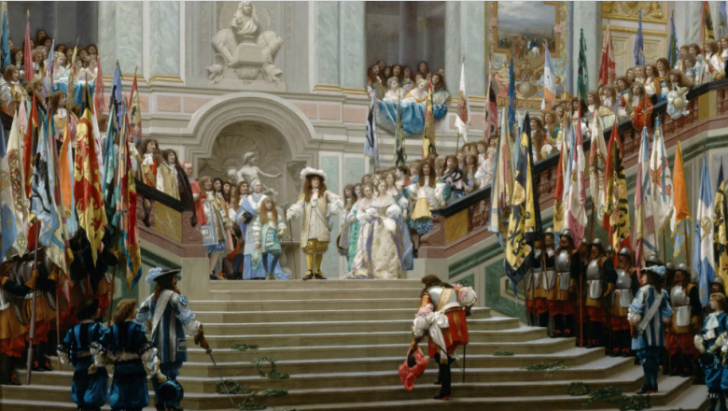
Answer the question or define the term for each:

Rise of Absolute Monarchy in France: The World of Louis XIV
- How did Cardinals Richelieu and Mazarin help set the groundwork for Louis XIV’s absolute rule?

- How did the Fronde impact Louis XIV’s reign?
People to Know
- Louis XIV (r. 1643-1715)
- Frederick William (r. 1640-1688)
- Frederick William I (r. 1713-1740)
- Peter the Great (r. 1682-1725)

Years of Personal Rule
- How did Louis XIV maintain his own authority among the growing and long established nobility?

Versailles
- How did Louis XIV use Versailles to his advantage?

King by Divine Right
- How absolute was the absolute monarchy of Louis XIV?
Terms to Know
- Versailles
- “divine right of kings”
- Jansenism

Louis’s Early Wars
- With whom did Louis XIV continuously go to war with on his northern border and why?

Louis’s Repressive Religious Policies
- How did Jansenism help stir conflict between royal authority and the church?

- How did Louis XIV’s revocation of the Edict of Nantes backfire on him?
Key Events
1640 – Augustinus published
1643-1715 – reign of Louis XIV
1649-1652 – Fronde
1682 – reign of Peter the Great
1683 – Siege of Vienna by Ottoman Turks
1685 – Louis XIV revokes the Edict of Nantes
1700-1721 – Great Northern War

Louis’s Later Wars
- Describe how France and Britain fared in the War of Spanish Succession.

France after Louis XIV
- How did the renewed authority of the French parlements help weaken the authority of the king?

Central and Eastern Europe
- Why was most of central and eastern Europe considered politically weak areas?

Poland: Absence of Strong Central Authority
- How did the governmental structure of Poland and the liberum veto cause the eventual fall of Poland?

The Habsburg Empire and the Pragmatic Sanction
- Describe the difficulty in uniting regions and people of the Habsburg Empire?

Prussia and the Hohenzollerns
- How was Frederick William able to amass such a large army that his successor was able to acquire the title of King in Prussia?

- Describe the meaning behind the expression “while other states possessed an army, the Prussian army possessed a state.”

Russia Enters the European Political Arena
The Romanov Dynasty
Peter the Great
- How are Louis XIV and Peter the Great similar?

- Describe Peter the Great’s transformation of Russia from fragile power on the periphery of Europe to a prominent European power

Russian Expansion in the Baltic: The Great Northern War
- How did the great Northern War benefit Russia?

- What did the city of St. Petersburg symbolize?

Please read the “IN PERSPECTIVE” section for an overview of the chapter.

