Unit IV – A Question of Sovereignty
(4-3) Scientific Revolution – pg. 203 – 218
Guided Reading Questions
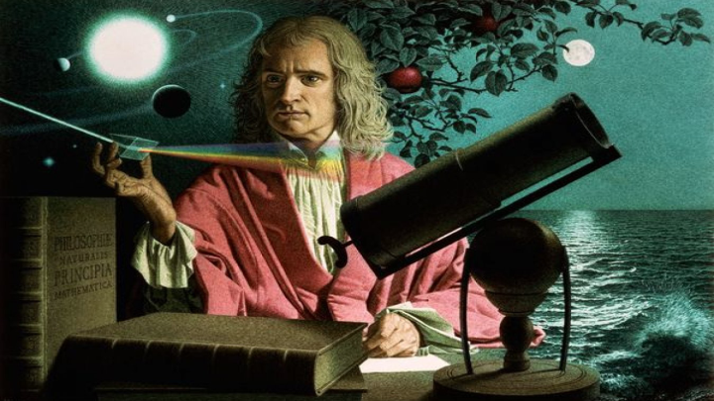
Answer the question or define the term for each:

New Directions in Thought and Culture in the Sixteenth and Seventeenth Centuries
- What two factors simultaneously challenged European thought and culture in the 16th and 17th centuries?

People to Know
- Nicolaus Copernicus (1473-1543)
- Tycho Brahe (1546-1601)
- Johannes Kepler (1571-1630)
- Francis Bacon (1561-1626)
- Galileo Galilei (1564-1642)
- René Descartes (1596-1650)
- Thomas Hobbes (1588-1679)
- John Locke ((1632-1704)
- Isaac Newton (1642-1727)

The Scientific Revolution
- Why might the term “revolution” be inaccurate in describing the Scientific Revolution?

Nicolaus Copernicus Rejects an Earth-Centered Universe
- How was Nicolaus Copernicus’s work “revolution-making”?

- Describe the Ptolemaic system as enhanced by Aristotle.

- How impactful was Copernicus’s work soon after it was published?
Terms to Know
- geocentricism
- Ptolemaic model
- heliocentric
- empiricism
- mechanism
- “institutions of sharing”

Tycho Brahe and Johannes Kepler Make New Scientific Observations
- How did Johannes Kepler impact the study of astrology and how did Tycho Brahe help to contribute to that impact?

Galileo Galilei Argues for a Universe of Mathematical Laws
- How did Galileo change how we view the universe?

Isaac Newton Discovers the Laws of Gravitation
- What final piece of information did Isaac Newton contribute to the problem of explaining planetary motion?
Key Events
1543 – Copernicus publishes work on heliocentricism
1609 – Kepler publishes The New Astronomy
1620 – Bacon publishes Novum Organum
1651 – Hobbes publishes Leviathan
1687 – Newton publishes Principia Mathematica
1689-90 – Locke publishes his work on government

Philosophy Responds to Changing Science
Nature as Mechanism
- Describe the idea of mechanism and how it impacted European thought.

Francis Bacon: The Empirical Method
- Describe Bacon’s impact on European thought.

René Descartes: The Method of Rational Deduction
- How is Descartes’s method of reasoning different from Bacon’s? What is the difference between induction and deduction?

Thomas Hobbes: Apologist for Absolute Government
- Describe the idea behind Hobbes’s “social contract”.

- Under Hobbes’s ideas, what role does the ruler have under the “social contract?”

John Locke: Defender of Moderate Liberty and Toleration
- How did John Locke view human beings?

- What are rules/laws that govern Locke’s beliefs about government?
Trust –

Toleration –

Blank Canvas Mind –

The New Institutions of Expanding Natural Knowledge
- How are late Middle Age and Reformation views on knowledge different from those that came after during the “scientific revolution”?

- How might the “institutions of sharing” of the 17th century be compared to TED Talks/Ed of the 20th/21st centuries?

Please read the “IN PERSPECTIVE” section for an overview of the chapter on page 234.

