Unit V – A Shifting Society
(5-3) The Cause of Liberty – pg. 291 – 301
Guided Reading Questions
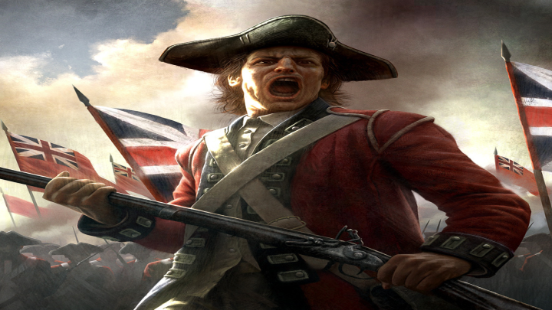
Answer the question or define the term for each:

Mid-Eighteenth-Century Wars
People to Know
- Maria Theresa (r. 1740-1780)
- William Pitt (s. 1757-1768)
- King George III (r. 1760-1820)
- George Grenville (s. 1763-1765)

- How did Europeans view war and peace before the Enlightenment?

The War of Jenkin’s Ear
- What was this war fought over (besides the obvious)?

The War of the Austrian Succession (1740-1748)
- Describe the relationship between Austria and Hungary?
Terms to Know
- enlightened absolutism
- customs*
- Common Sense

- How was France able to drawn in Britain to the conflict and what was the consequence of this action?

The “Diplomatic Revolution” of 1756
- Explain how the Convention of Westminster (1756) benefited the following:
Britain –
Key Events
1739-48 – War of Jenkins’s Ear
1740-48 – War of Austrian Succession
1756-63 – Seven Years’ War (F&I War)
1763 – Treaty of Paris (1763) signed
1764 – Sugar Act passed
1765 – Stamp Act passed
1767 – Townshend Acts passed
1770 – Boston Massacre
1773 – Boston Tea Party
1774 – Intolerable Acts passed
1774 – 1st Continental Congress meets
1775-1783 – American Revolution
1775 – Battle of Lexington & Concord
1775 – Common Sense published
1776 – Declaration of Independence
1778 – French join American cause
1781 – Battle of Yorktown
1783 – Treaty of Paris (1783) signed
1788 – federal Constitution approved in U.S.

Prussia –

Austria –

The Seven Years’ War (1756-1763)
- What two factors helped save Prussia from destruction during the Seven Years’ War?

- How was William Pitt and the British able to defeat the French in the French & Indian War?

- How has the war made Britain a world power?

The American Revolution and Europe
Resistance to the Imperial Search of Revenue
- What two problems faced the new imperial Britain following the Seven Years’ War?

- Describe the vicious cycle that occurred between British Parliament and their American colonies over taxation.

The Crisis and Independence
- How did the Intolerable Acts and the Quebec Act contribute to further resentment from Britain’s American colonies?

American Political Ideas
- What impact did the Commonwealthmen have on the American colonies?

Events in Great Britain
- How did events in America help to influence reform in Britain and the rest of Europe?

Broader Impact of the American Revolution
- Briefly describe the overall impact American new government had on Europe?

Please read the “IN PERSPECTIVE” section for an overview of the chapter.

