Unit VI – Revolution
(6-2) Radical Revolution – pg. 373 – 390
Guided Reading Questions
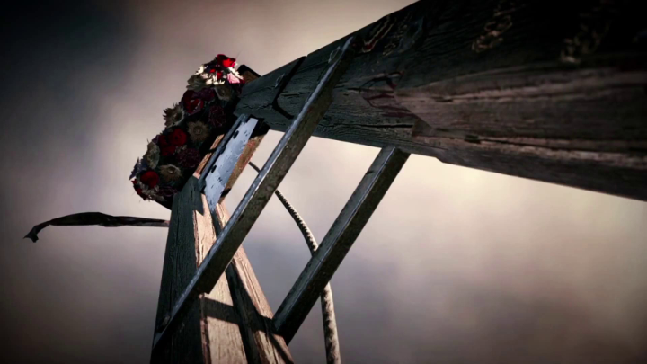
Answer the question or define the term for each:

The End of the Monarchy: A Second Revolution
People to Know
- Jacques Necker (1732-1804)
- Louis XVI (r. 1774-1792)
- Marie Antoinette (1755-1793)
- Maximilien Robespierre (1758-1794)

Emergence of the Jacobins
- What system of government was favored by the Jacobins and which Enlightenment thinker influenced them?

- How did each of the following believe war with Austria (and Prussia) would benefit themselves:?
  - Girondists –
Terms to Know
- Jacobins
- Girondists
- sans-culottes
- coalition*
- Reign of Terror
- Committee of Public Safety
- “republic of virtue”
- Thermidorian Reaction

  - Louis XVI –

- How was the Paris Commune different from the city council and what role did it play in the future events of the Revolution?

The Convention and the Role of the Sans-culottes
- What was the purpose of the Convention?

- What were the goals of the sans-culottes?

Key Events
1792
Apr – Legislative Assembly declares war on Austria
Aug – Riot at the Tuileries palace
Sept – September Massacres
Sept – the Convention is formed
Dec – Louis XVI put on trial for treason
1793
Jan – Louis XVI is beheaded
Feb – Convention declares war on Britain & Holland
Oct – Marie Antoinette is beheaded
1793-94 – Reign of Terror
1794
Jul – Robespierre is beheaded
Jul – Thermidorian Reaction
1795 – the Directory is established

- How are the Mountain, the san-culottes, and the Girondists the same? How are they different?

Europe at War with the Revolution
Edmund Burke Attacks the Revolution
- How might Edmund Burke be seen as a visionary or “prophet”?

Suppression of Reform in Britain
- How was Britain able to resist calls for reform?

The Second and Third Partitions of Poland, 1793, 1795
- How did the Revolution affect Poland? How did Poland affect the war/Revolution?

The Reign of Terror
War with Europe
- How might the Revolution have threatened the countries of the First Coalition in the following areas*?
    - social structures –

    - political systems –

    - economic interests –

- How did the Revolution take on a life of its own leading to the Reign of Terror*?

The Republic Defended
- Define levée en masse.

The “Republic of Virtue” and Robespierre’s Justification of Terror
- How did the “republic of virtue” make itself apparent in French society?

- How did Maximilien Robespierre’s beliefs and speech support the idea of a “republic of virtue” and what weapon does Robespierre suggest be used by this “republic of virtue”?

Repression of the Society of Revolutionary Republican Women
- How did the Reign of Terror affect the women of the Revolution?

De-Christianization
- In what ways did the “republic of virtue” attempt to de-Christianize France?

Revolutionary Tribunals
- During the Reign of Terror’s revolutionary tribunals, how was one defined as an “enemy” of the Revolution?

The End of the Terror
- How might the phrase “those who play with fire, often get burned” be applied to the end of the Reign of Terror?*

The Thermidorian Reaction
- How was the Thermidorian Reaction a reaction to the Reign of Terror?

Establishment of the Directory
- Explain the government established by the Constitution of the Year III.

- Who benefited the most from the French Revolution?

Removal of the Sans-culottes from Political Life
- How did the Directory fail to achieve or uphold the goals of the French Revolution?

Please read the “IN PERSPECTIVE” section for an Overview of the Chapter

