Unit VII – Political Turmoil
(7-1) The Political Compass – pg. 428 – 447
Guided Reading Questions
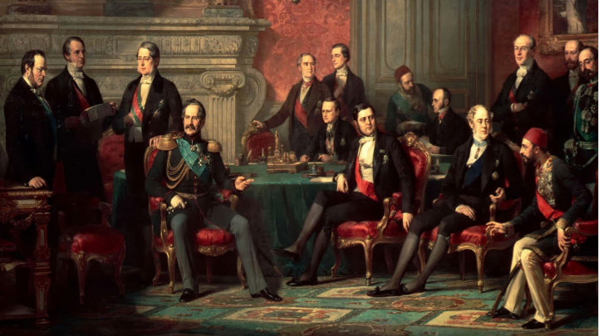
Answer the question or define the term for each:

The Conservative Order and the Challenges of Reform
People to Know
- Prince Metternich (1773-1859)
- Thomas Malthus (1766-1834)
- Louis XVIII (r. 1814-1824)

- What had been the goal of the Congress of Vienna?

The Conservative Order
- What was the goal of the Concert of Europe?

The Congress System
The Domestic Political Order
Conservative Outlooks
- What are the pillars of conservatism (throne, land, alter) and what had forced them to react and stand together?
Terms to Know
- conservatism
- Concert of Europe
- congress system
- nationalism
- liberalism
- laissez-faire
- Carlsbad Decrees
- Congress of Troppau

- What are the basic beliefs of conservatism? (Please don’t confuse these with modern American politics)

- What problems did the nations of Europe face after the peace of 1815?

The Emergence of Nationalism and Liberalism
Nationalism
- How do nationalist belief a nation’s borders should be determined?

Key Events
1815 – Congress of Vienna
1819 –
Jul - Carlsbad Decrees issued in German states
Aug – Peterloo Massacre in Britain
Dec – Six Acts passed in Britain
1820 – Congress of Troppau
1823-1827 – France occupies Spain

- Why would nationalists be in conflict with the Congress of Vienna?

- How did nationalism impact languages across Europe?

- What is one of the keys to nationalism and represents one of its greatest challenges?

- What regions of Europe experienced nationalistic pressure?

Early-Nineteenth-Century Political Liberalism
- What are the basic beliefs of liberalism? (Please don’t confuse these with modern American politics)

- To liberals, who should be in charge of society?

- Nearly as important as what liberals favored, what did they not favor?

Classical Economics
- Describe the liberal economic view.

- Why would liberals be at odds with the working class?

- How does Malthus draw a connection between population and economics?

- Describe the “iron law of wages”.

Relationship of Liberalism to Nationalism
Conservative Restoration of Europe
Liberalism and Nationalism Resisted in Austrian and the Germanies
- How did nationalism threaten the Austro-Hungarian Empire?

- Briefly summarize the events that led to the Carlsbad Decrees.

Postwar Repression in Great Britain
- How did the Corn Law and Combination Law contribute to unrest among the lower social classes?

- What was the purpose of the Six Acts?

Bourbon Restoration in France
- What was the White Terror?

- Beyond the monarchy, how could Louis XVIII’s reign be seen as undoing the values and ideals of the French Revolution?

The Spanish Revolution in 1820
- What precedent was set by the Congress of Troppau?

- How had international affairs changed under the congress system? How did this lead to international restraint? What affect did this have on stability in Europe?

