Unit VII – Political Turmoil
(7-2) Nationalism and Politics – pg. 447 – 461
Guided Reading Questions
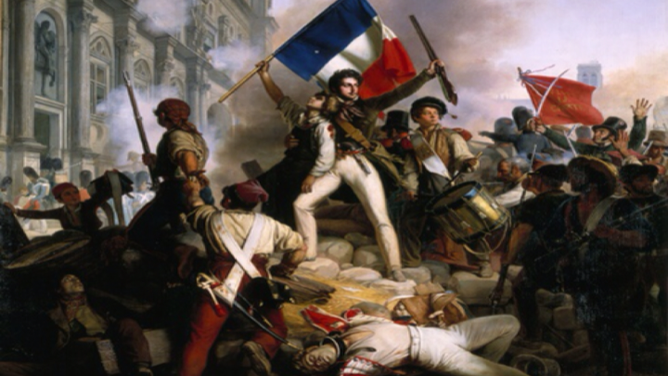
Answer the question or define the term for each:

The Conservative Order Shaken in Europe
People to Know
- Tsar Nicholas I (r. 1825-1855)
- Charles X (r. 1824-1830)
- Louis-Philippe (r. 1830-1848)

Revolt Against Ottoman Rule in the Balkans
- What was the “Eastern Question”?

- Why were each of the following interested in the Ottoman Empire?

Russia/Austria –

Britain/France –

- What relationship did Serbia have with its neighbors?

Ottoman Empire –
Terms to Know
- Creole
- peninsulares

Austria –

Russia –

Russia: The Decembrist Revolt of 1825
- Besides governmental change, what did the secret societies within Russia agree upon?

- What was being demand in the Decemberist Revolt?

- Why was Nicholas I resistant to the socioeconomic reforms need to reform Russia?

Key Events
1810-1830 – Latin American independence
1821-1830 – Greek Revolution
1825 – Decemberist Revolt
1830 – Serbia gains independence
1830 – July Revolution in France
1830 – Belgium gains independence
1832 – Britain passed Great Reform Bill

- Explain Official Nationality’s meaning behind their slogan: “Orthodoxy, Autocracy, and Nationalism”.
Orthodoxy –

Autocracy –

Nationalism –

- How was the treatment of Poland revealing of the political mood/atmosphere in Europe by major powers like Russia?

Revolution in France (1830)
- How did Charles X’s actions upset liberals and seem to turn back the clock to 1789?

- How did the Revolution of 1830 prove to be both liberal and conservative?
liberal –

conservative –

Belgium Become Independent (1830)
- Under a nationalistic view, why was Belgium independence from Holland inevitable?

- How was Belgium able to gain independence without interference from the major powers?

The Great Reform Bill in Britain (1832)
- How did the spirt of compromise combined to lead to the Great Reform Bill of 1832?

- How did religion factor into British-Irish relations and in turn impact British politics?

- How was the Great Reform Bill of 1832 seen as a success against revolutionary action?

The Wars of Independence in Latin America
Wars of Independence on the South American Continent
- How were the Latin American independence movements different than the Haitian Revolution?

- How did Napoleon impact Latin American independence?

Independence in New Spain
- Why would the independence of New Spain, like most of Latin American, be considered a conservative movement?

Brazilian Independence

Please read the “In Perspective” section for and overview of the chapter

