Unit VII – Political Turmoil
(7-3) The Perils of Industry – pg. 462 – 480
Guided Reading Questions
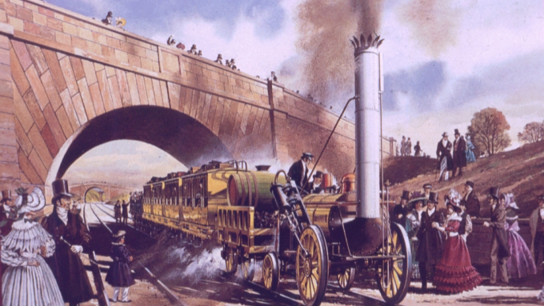
Answer the question or define the term for each:

Economic Advance and Social Unrest
People to Know
- William Lovett (1800-1877)

Toward an Industrial Society
- How did Britain come to dominate the 19th century?

Population and Migration
- How did industry impact the population of and settlement of Europe?

- How did over-population impact the cities of Europe?

Terms to Know
- proletarianization
- Chartism
Railways
- How did industrialism grow on itself and have a reciprocal relation to the railway of Europe?

- How did the Revolution of 1830 prove to be both liberal and conservative?
liberal –

The Labor Force
- Why is it difficult to describe the labor force of the early 19th century?
Key Events
1814 – Locomotive invented
1825-1850 – Age of Railways
1833 – English Factory Act
1838 – Chartism begins
1845-1847 – Irish Potato Famine

The Emergence of a Wage-Labor Force
- Describe the emergence of the wage-labor force.

- How did urban artisans benefit from industrialization?

- How does the French practice of confection relate to modern times?

Working-Class Political Action: The Example of British Chartism
- While ultimately a failure in Britain, what lesson was taken away from the Chartism movement?

Family Structure and the Industrial Revolution
The Family in the Early Factory System
- How did industrialization of the textile industry impact male-female roles in the workplace?

- How did the concern over child labor impact working hours in factories?

Women in the Early Industrial Revolution
Opportunities and Exploitation in Employment
- How was the early Industrial Revolution a win-lose situation for women?

- Why and how were women especially vulnerable to the pressures of an industrializing economy?

Changing Expectation in the Working-Class Marriage
Problems of Crime, Order, and Poverty
New Police Forces
- Why was a police force necessary for the growing European societies of the 19th century?

Prison Reform
- How were prisons reformed during the 19th century? What explains this change?

- For prisons like the ones found in France, what was their new purpose?

