Project 1 Newspaper


Create and complete newspaper articles on the various topics covered in the unit we’re studying. The articles should give the reader a clear overview of each topic, and you need to be as creative as possible in writing the articles. A sample template can be found on the website to give you an idea of how this newspaper should look when complete.
http://www.makemynewspaper.com/ is a wonderful resource for those wanting to do an online paper.

Requirements:
4-page minimum (2 pages per person)
Go beyond the list provided to give at least 2 additional articles on topics of your choosing from the unit

RUBIC FOR ASSIGNMENT FOUND ON THE LAST PAGE!

Unit 1: In the beginning...

Neolithic Revolution
Ice Age
Sumerians
Ancient Egypt
Phoenicians
Babylonians/Hammurabi’s Code
Civilization
The Great Pyramids
Israelites
Cro-Magnons v. Neanderthals
Persian Empire (650B.C.–330B.C.)

Unit 2: Ancient Greece

Alexander the Great
Ancient Athens
Ancient Sparta
Battle of Marathon
Battle of Plateau
Battle of Thermopylae
Golden Age of Greece
Greco-Persian War
Greek Democracy
Greek Philosophy
Greek Science
Greek Theatre
Hellenistic Kingdoms
Homer’s Iliad & Odyssey
Peloponnesian War

Unit 3: The Rise and Fall of Rome

Barbarian Invasions
Battle of Adrianople
Colosseum
Council of Nicaea
First/Second Triumvirate
Gracchi brothers
Great Fire of Nero
Marius and Sulla/Civil War
Pantheon
Persecution of the Christians
Punic Wars
Rise of Christianity
Rise of Julius Caesar/Civil War
Roman Empire
Roman Republic
Roman Roads
Trajan
Tribunes

Unit 4: The Dark Ages

Battle of Tours/Charles Martel
Catholic Church
Charlemagne
Chivalry
Code of Justinian
Emperor Justinian
Feudalism
Holy Roman Empire
King Richard I
King John I
Knight Templar
Magna Carta
Muslim Conquest
Norman Invasion
Plague of Justinian
Roman Catholic Church
St. Benedict
Vikings/Leif Erikkson

Unit 5: The Middle Ages

1st Crusades
2nd Crusades
3rd Crusades
4th Crusades
Battle of Agincourt
Battle of Castilian
Battle of Crecy
Battle of Poitiers
Black Death
Fall of Constantinople (1453)
Genghis Khan
Gothic Architecture
Great Schism
Guilds
Hundred Years War
Inquisition
Joan of Arc
Medieval China
Middle Ages Universities
Mongol Empire
Rise of Spain
Siege of Orleans
Silk Road
Travels of Macro Polo

Unit 6: Renaissance and Discovery

Amerigo Vespucci
African Slavery
Age of Exploration
Bartholomew Dias
Christopher Columbus
Columbian Exchange
Dante Alighieri
English Colonization
Ferdinand Magellan
Francis Drake
Hernando Cortéz
Italian Renaissance
Leonardo da Vinci
Lorenzo de’ Medici
Michelangelo
Middle Passage
Niccolò Machiavelli
Renaissance Art
Spanish Conquistadors
The Canterbury Tales
The Conquering of the Americas
The Divine Comedy
The Renaissance
Triangle Trade
Vasco da Gama
William Shakespeare’s Work
Works of William Shakespeare

Unit 7: Crisis of Faith

Council of Trent
English Civil War
Enlightenment
French Civil War
Galileo
Glorious Revolution
Henry VIII
Isaac Newton
John Locke
King Philip II (Spain)
Life of Henry VIII
Life of Martin Luther
Louis XIV
Martin Luther
Montesquieu
Oliver Cromwell
Peace of Westphalia
Queen Elizabeth
Queen Mary I
Reformation
Scientific Revolution
Spanish Armada
Thirty Years War
Voltaire
William and Mary

Unit 8: Revolutionary World

Gen. George Washington
American Revolution
Battle of Austerlitz
Battle of Waterloo
Battle of Yorktown
Boston Tea Party
Boston Tea Party

Continental System
French Revolution
Jean Paul Marat
King Louis XVI
Marie Antoinette
Maximilien Robespierre
Napoleon Bonaparte
Napoleon’s “3-Mistakes”
Napoleon’s Hundred Days
Napoleon’s Invasion of Russia
Napoleonic Code
Napoleonic Wars
Seven Years’ War
Storming of the Bastille
The Terror

Unit 9: Industrial Imperialism

James Watts
Assembly line/Mass Production
Berlin Conference
Charles Dickens
Communist Manifesto
Crimean War
Crisis in the Balkans (1908)
Feminism
Franco-Prussian War
German Unification
Giuseppe Garibaldi
Henry Bessemer
Herbert Spencer
Imperialism
Imperial Wars
Industrial Revolution
Italian Unification
James Cook
Karl Marx
Luddites
Manchester, England
Otto von Bismarck
Queen Victoria
Railroads
Social Darwinism
White Man’s Buren
Revolution of 1848
Steam Engine
Technology of Industrial Revolution Zionism

Unit 10: The Great War

Archduke Ferdinand
Armenian Genocide
America’s Entry into World War I
Assassination of Archduke Ferdinand
Battle of Gallipoli
Battle of Marne
Battle of Somme
Battle of Verdun
Christmas Truce
Czar Nicholas II
Fall of Empires
February Revolution
Grigory Rasputin
Kaiser Wilhelm II
Mandate System
October Revolution
Rape of Belgium
Russian Civil War
Russian Revolution
Schlieffen Plan
Spanish Influenza
Treaty of Versailles
Trench Warfare
Vladimir Lenin
Woodrow Wilson
World War I
World War I Technology

Unit 11: World War II

Adolf Hitler
Appeasement
Attack on Pearl Harbor
Battle of Britain
Battle of Coral Sea
Battle of Kasserine Pass
Battle of Kursk
Battle of Leyte Gulf
Battle of Midway
Battle of Stalingrad
Battle of the Bulge
Benito Mussolini
Casablanca Conference
Enabling Act
Fascism
Franklin D. Roosevelt
Gen. Dwight Eisenhower
Gen. Erwin Rommel
Gen. George Patton
Hiroshima/Nagasaki
Iwo Jima/Okinawa
J. Robert Oppenheimer
Joseph Stalin
Miracle at Dunkirk
Munich Conference
Nazi Germany’s Expansion 1940
Nazism
Neville Chamberlin
Operation Overlord
Operation Barbarossa
Potsdam Conference
Premier Tojo
Rise of Hitler
Tehran Conference
Tokyo Firebombing
Winston Churchill

Unit 12: Cold War and Terrorism

38th Parallel
Apartheid
Arab Spring
Berlin Airlift
Berlin Wall
Cold War
Cuban Missile Crisis
Decolonization

European Union
Fall of the Berlin Wall
Fall of the Soviet Union
Globalization
Holocaust
Israel
Kim Jong Il
Korean War

M.A.D.
Marshall Plan
Mikhail Gorbachev
NATO
Nuremberg Trials
Sputnik
Terrorism around the World
United Nations

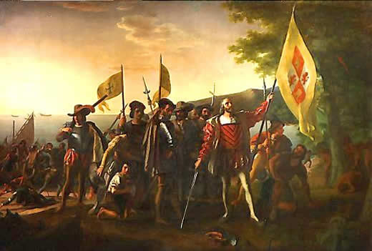

Volume 1 November 29, 2016
Global Gazette
After careful analysis of Columbus’ discovery in 1492, it has been concluded that what we have believed to be the Indies and part of Asia is indeed a “New World”.
This new development arose out of observations made by Italian cartographer Amerigo Vespucci that the large land mass first discovered by Columbus in the late 15th century does not correspond to the charts and maps made by European explorers of the Asia continent. From this, Vespucci believes the only logical explanation is that the land first discovered by Columbus and surveyed by those that came after is in fact a new continent.
If this is true, it opens up a whole “new world” (pun intended) of questions: How big is this new land? What profit can be made from this new land? Who lives here and how many are there? What will this new world be called?
In regards to the name of this new territory, many have discussed calling the new world “Columbia” in honor of Christopher Columbus who is believed to have been the first to discover it. However, other believe the credit should go to Amerigo Vespucci who has brought the revelation of this monumental development to light and should thus be called “America”
Continued on page 5
New World Discovered!!!
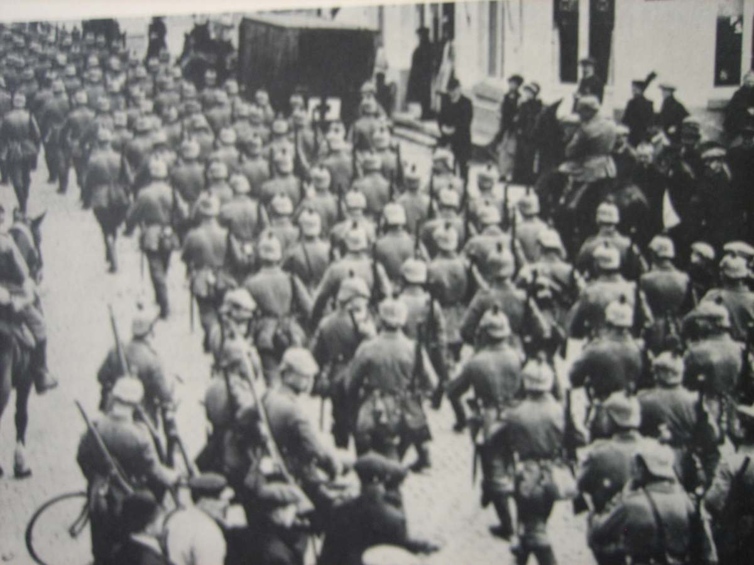
British colonies in America in a state of revolution say news reporters from Boston. After last years incident that the British colonists have label the “Boston Massacre”, many have wondered how long it would take for a general rebellion to being in the British colonies.

Continued on page 4
The End of an Empire?
As barbarian trips continue to invade and conquer territory once held by the Roman Empire, many wonder if this is a sign of the beginning of the end. Last year, the Roman Empire sent out notice to the island of Brtiania that the empire would know longer be able to protect it and would be pulling out of the island in the coming year. The pressure of the Huns in eastern Europe has already put a tremendous strain on the Goths living there who have begun a massive migration into the Eastern Empire.
Continued on page 2
WAR!!!
Yesterday, August 3rd, the Germans violated Belgium neutrality by invading their country on their warpath to France. The British who only two days ago were about to declare themselves neutral in the German war have made it clear that the Germans have crossed the line and that war with Britain is inevitable. This comes only a few days after Russia began mobilizing its army on the German-Austrian boarder in response to
Continued on page 4

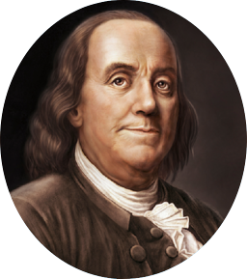
… the assassination of the Austrian Archduke Franz Ferdinand on June 28th at the hands of a Serbian terrorist named Gavrilo Princip
Within a month after this brutal terrorist attack, Austria began bombing Serbia as Russia began to mobilize on the Austrian boarder as the ever-present protector of Serbia and the Slavic people. It is still uncertain if Austria was given favor by Germany for this aggressive act, but whatever the case the Germans declared war on Russia to support Austria as part of their alliance with that nation. France was then obligated to become involved in a war over a similar alliance with Russia.
This threat of a two front conflict with both Russia and France on both sides of Germany is no doubt to blame for Germany’s disregard to Belgium’s neutrality in order to subdue the French forces quickly before have to commit to a much larger conflict with Russia.
It is uncertain if Britain will commit troops to France to help defend France and avenge Belgium, but this is to be certainly the largest conflict that has happened in Europe in over 100 years. Whatever comes of this war on the horizon, it safe to say that all of Europe, or even the world will never be the same again.
“They who can give up essential liberty to obtain a little temporary safety deserve neither liberty nor safety.”
- Benjamin Franklin

Martin Luther declared an outlaw.
Yesterday the Catholic Church made an official declaration concerning the new teaching of former Catholic monk, Martin Luther.
In a statement that has spread across Europe nearly as quickly as Martin Luther’s Ninety-Five Thesis, the Catholic Church announced that Martin Luther is a heretic wanted by the Catholic Church for crimes again God. This comes after Martin Luther turned down a request from the Vatican to come to Italy for a conference on his teachings in Northern Germany. Many in Northern Germany supported Luther’s criticisms of the Catholic Church and have called for reform along side Luther.
While Luther is not the first person to challenge the Church’s corrupt use of power to deal with financial problems, he is the first person to get wide-spread support from local rulers that are committed to protecting him. Whether or not Luther can continue to evade the reach of the Catholic Church is uncertain, but rumor of a German translation of the Bible being done by Luther while in hiding may be a sign that Luther is not done challenging the power of the Catholic Church.
A Call to Arms

The Pope recently launched a holy war against the infidels in the Middle East who have conquered and defiled the precious holy city of Jerusalem. This “crusade” as it’s being called is the first time that the nations of Christendom have come together for a religious calling. Many knights and warriors from across the kingdoms of Europe have already headed the call and are advancing the city of Constantinople as a rallying point before the military expedition into the Middle East to reclaim Jerusalem.
Editorials

The Great Pestilence that has beset Europe is horrible thing! Those that would blame this curse of God as a disease or plague are blinded by their own sin! This is a message from God for the people of Europe to turn away from their wicked ways and follow him more dearly. Mankind has lost their way and God has found fit to punish us for our disbelieve, our lustful and unloving hearts, our pride, and our worldly ways.
Martha Townsberry, 37

The crazies in this fair city talk as if this is some sort of “wrath of God” or something. I don’t know about all that, but I have seen an awful lot of rats in the city lately. I think it has something to do with them, but no one is talking about it.
Daniel Brown, 43
Expandable Ideas:
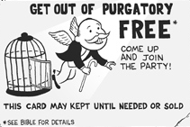
Advertisement

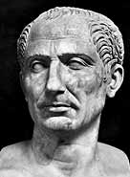
Gaius Julius Caesar
100B.C. – 44B.C

Julius Caesar, 55, a politician, general, and consul for life was stabbed to death in the halls of the Senate on March 15 on his way to give a speech. A former member of the political alliance known as the First Triumvirate, Caesar was a very skilled politician becoming consul five times in his political career…..
Obituaries

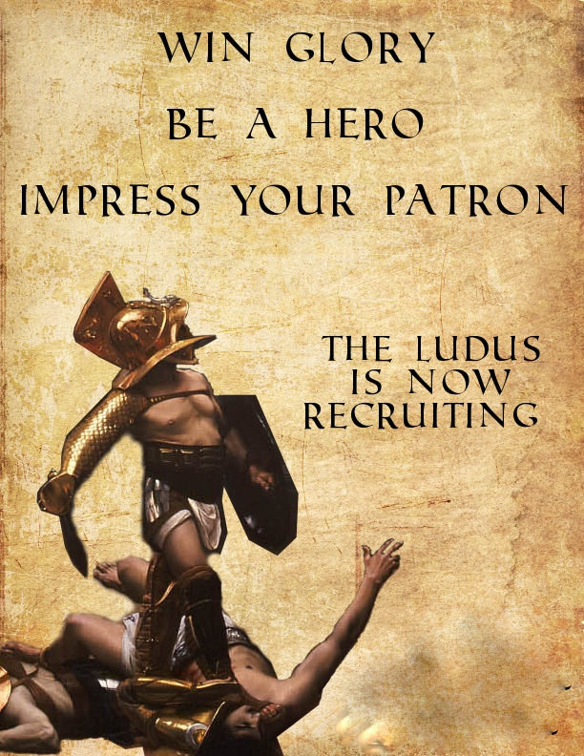
Entertainment

Student Names:

Project 1 Rubric
 | Graded Requirements | Points Possible | Points Deducted | Student/Teacher Notes
 | ALL Terms used | 25% of grade
 | Meaningful information on ALL terms* | 25% of grade
 | Photos/Images accompanying 10% of articles** | 50% of grade
 | Total | 100%
 |  | Score

*__Meaningful information is information that shows understanding into the importance of your topic/event as to show the reader why history remembers this topic/event and why it is covered. Unimportant information such as birthdays, or fluff (words or sentences used to fill space, but don’t provide important information or add understanding to the reader) will not be counted as “MEANINGFUL INFORMATION”
** Photos or images should relate directly to the topic of the article in which the photo or image is placed.

